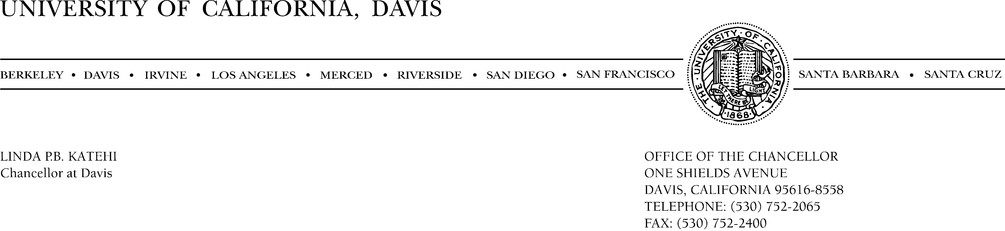

January 24, 2012

President Mark G. Yudof
Office of the President
University of California
1111 Franklin Street
Oakland, CA 94607

RE: UPDATE ON USE OF POLICE FORCE

Dear Mark,

I write in response to your letter of January 10 in which you request an update on actions we have taken when considering the use of police force. As you can imagine, we have expended much time and effort on this topic since the events of November 18, 2011. Working with our Council of Vice Chancellors as well as the many staff who have managed recent events, we have assembled a draft set of values that would guide any response to protests/occupations. These values stress patience, collaboration and identification of alternatives. We have broadened our consultation on these values now that the academic quarter is well underway.

While we will continue to develop and refine our strategies and tactics throughout the academic year, I am pleased to respond to the suggestions in your letter as highlighted below.

Designated Senior Official: I agree with your suggestion for designating a senior official to be present in the extent of a major demonstration. This would help to ensure any decision to use force is consistent with academic values and campus culture. I have designated Provost and Executive Vice Chancellor Ralph Hexter (professor of classics and comparative literature) and Vice Chancellor of Student Affairs Fred Wood (senior lecturer of chemistry) to serve in this capacity.

Mutual Aid: Our Police Department continues to ensure mutual aid officers assigned to an event on campus are well supervised. This close supervision has been accomplished by the following means:

- Pre-event briefings with commanders from all mutual aid agencies. This briefing typically takes place several days prior to an event when possible.
- Since the event of November 18th, the use of force has been formalized in the Operations Plans which are shared with all allied agencies.

President Mark G. Yudof
January 24, 2012
Page 2

- A Joint Command ensures that all agencies on site are receiving the same direction and discussion can be held with all key players as the events unfold. This recognizes that each mutual aid agency’s use of force policy may differ.
- Routine email updates to all mutual aid agencies as to the status of an upcoming event is common and ensures all are informed.
- Mutual aid officers are provided a UC Davis Police radio so that communication during the event is consistent.

Notification of rights and responsibilities: The UC Davis Police Department has held preliminary meetings with members of many student communities to discuss the “Know your Rights” model while protesting and the possible consequences associated with violating policy and law. A “Know your Rights” card is currently being drafted by the Acting Police Chief, student volunteers and a Letters and Science Student Affairs Officer. The intent of this card is to communicate in writing what is being told to protestors at an event. It is expected to contain information along the lines of the existing campus free speech brochure: “Freedom of Expression, Peaceful Protest, and Civil Disobedience on Campus: Rights and Responsibilities” (http://csi.ucdavis.edu/forms/peaceful_protest.pdf).

In addition to these activities, we have undertaken other tasks to improve our response to demonstrations.

Event Management Structure: We restructured our Emergency and Crisis Management Team this summer in anticipation of protest activity related to the state budget. This Team’s membership is again being refined and has been supplemented with a Protest Management Group that has been meeting at least weekly to address both current events and to improve our system for future events. This group has discussed various factors to successfully manage any future occupations.

Engagement Team: We are finalizing elements of an “Engagement Team” that will be prepared to engage in open conversation with those who may be involved in an occupation. As currently envisioned, this team will consist of several staff trained in mediation and negotiations. Later this quarter, the initial team will be supplemented with additional members yielding much broader representation. In addition, the Davis Division of the Academic Senate may also identify a group of faculty members who will observe and potentially engage with those involved in an occupation.

Police Review/Advisory Board: It is our intent to establish a police advisory and review group. Our acting police chief will be in contact with the National Association for Civilian Oversight of Law Enforcement to identify some of the best functioning groups of this kind that can serve as a model.

Other Police Initiatives: Other areas that are currently under review and development related to police department Use of Force and policy review include:
President Mark G. Yudof
January 24, 2012
Page 3

- Leadership course implemented for all police department supervisory staff.
- Review of Use of Force Policy in recognition of the lack of a comprehensive crowd management policy.
- As suggested at the recent legislative hearings, Acting Police Chief Carmichael, Vice Chancellor Meyer and senior police staff are reviewing crowd management policies from other police departments for potential adaptation and implementation into the UC Davis Police Department.
- A request for a proposal from LEXIPOL, a provider of risk management resources and public safety department policy. UC Davis Police has a long standing tradition of developing policy internally and it believes this new approach will result in more thoroughly developed policies and procedures. Included in this request for information is our commitment to ensuring department policy meets and is accredited by Commission on Law Enforcement Accreditation standards. Such national accreditation is not widespread in California and would reflect a dedication to high quality community based police services.
- UC Davis Police administration will implement a series of table top exercises throughout the organization to ensure consistent training and education for protest response. This may include implementing models from other agencies adapted to meet the needs of the UC Davis campus community.
- The Occupy movement is a relatively new approach to demonstration. Law enforcement agencies across the country continue to refine their approach in a manner that balances the needs of their communities. The UC Davis Police Department has invited other communities that have successfully managed incidents, such as the City of Santa Rosa Police Department, to present their perspective on recent successful operations related to occupy events.

We recognize the disruption caused by events on our campus November 18, 2011. We are fully committed to developing processes that prevent that outcome from ever being repeated. We also are dedicated to taking a leadership role in adopting practices that ensure we engage with protestors.

Sincerely,

Linda P.B. Katehi
Chancellor

/lah

